Assignment 1

Performance testing and JMeter Overview

Ramish - Shabbir

QA INT

Non-functional Testing

Non-functional testing is a type of software testing that checks how well a system performs, how secure it is, how easy it is to use, and how reliable it is.

Types

There are different types of non-functional testing, including

Performance testing

Performance testing is evaluating how well a system performs under different load conditions to identify bottlenecks and ensure required performance criteria.

Security testing

Security testing is the process of testing software to identify vulnerabilities and weaknesses that can be exploited by attackers.

Usability testing

Usability testing is evaluating how easy and user-friendly a system is to use

Compatibility testing

Compatibility testing is checking whether the system works correctly with different hardware, software, and operating systems.

Scalability testing

scalability testing is evaluating how well the system can handle increased load and user traffic.

These testing techniques help to identify potential issues and ensure that the system works well in different situations and environments.

Tools

Some of the most popular tools for performance testing include Apache JMeter, LoadRunner, and Gatling. These tools are widely used in the industry and have a large community of users and developers. Other popular tools include BlazeMeter, NeoLoad, and Silk Performer.

These tools provide features such as load generation, monitoring, and reporting, and can be used to test different types of applications, such as web applications, mobile applications, and APIs. The choice of tool depends on the specific requirements of the project, the budget, and the level of expertise of the testing team.

JMeter Overview

JMeter is a Java-based open-source tool designed to test the performance and functional behavior of web applications, APIs, and databases. It can be used to simulate multiple users and requests, measure response times, and analyze system resources like CPU and memory usage.

JMeter provides a user-friendly graphical interface for creating and running test plans, including test scripts and scenarios. It supports a wide range of protocols and technologies, including HTTP, HTTPS, SOAP, REST, FTP, JMS, and JDBC.

JMeter can be used for load testing, stress testing, and functional testing, and can generate reports and graphs to help identify performance bottlenecks and issues. It is highly extensible and customizable, with a large community of developers who contribute to its development and support.

How JMeter works

Sending Request to the target server

Then server will respond to its call

JMeter saves all responses

Collect and save all statistical info

Then finally generate the test report

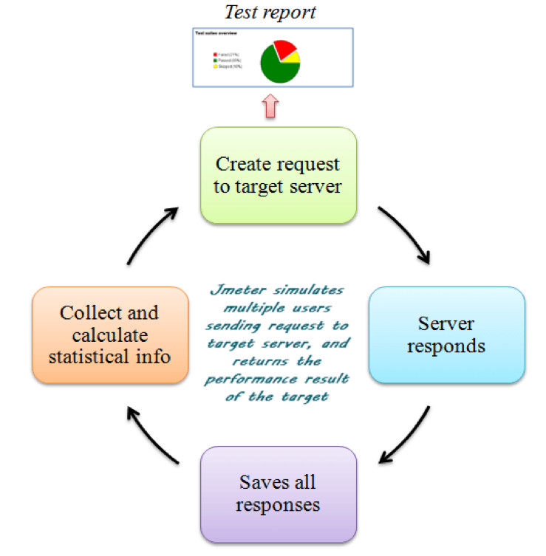

JMeter Element

There are Different types of Components in JMeter called the JMeter Elements. Each element is designed for a specific purpose.

Thread Groups

It is basically a collection of threads and each thread represent the one user.

Sampler

Samplers are different type of request send by thread group. User request could be FTP request, HTTP request or JDBC request etc.

Listeners

Listeners shows the result of the test execution. They can show result in different format such as tree (HGTML format), table, graph or log files (text file).

Configuration Elements

These elements are using for setting the default variables which we can use by samplers. Commonly used configuration elements in JMeter are HTTP cookie manager, HTTP request defaults, Login Config Element or FTP cookie manager etc.